CS598 DL HW6 Report

Zhenbang Wang(zw11)

1. Training Process:

epoch 0 epoch 40

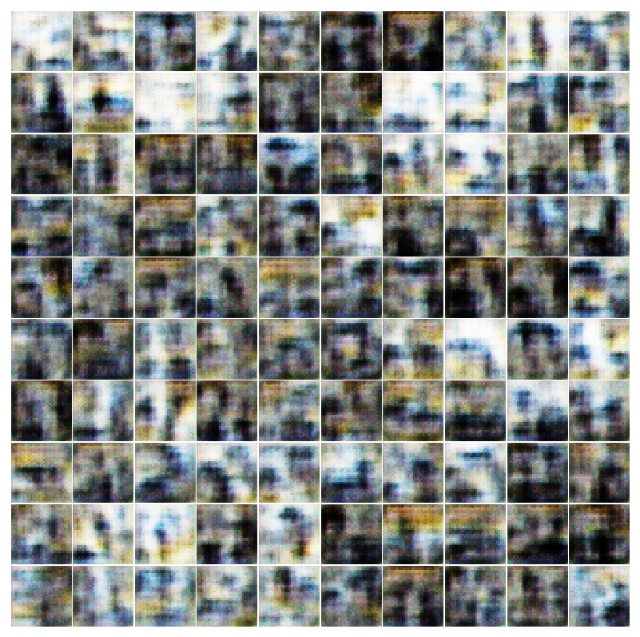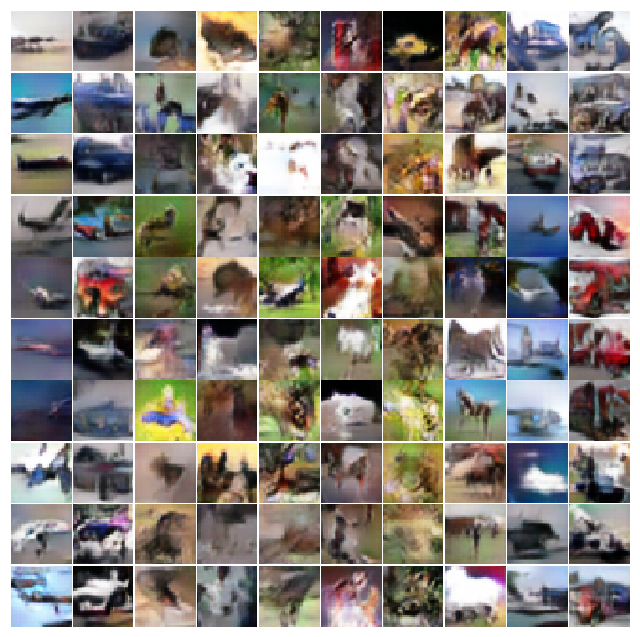

epoch 80 epoch 120

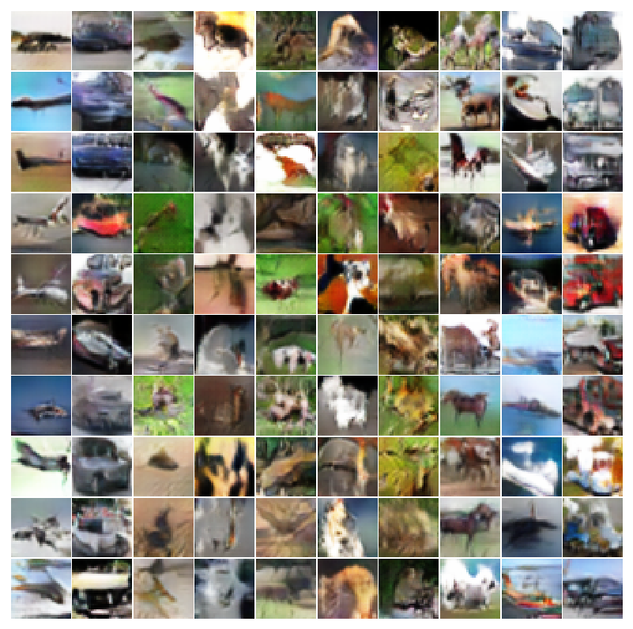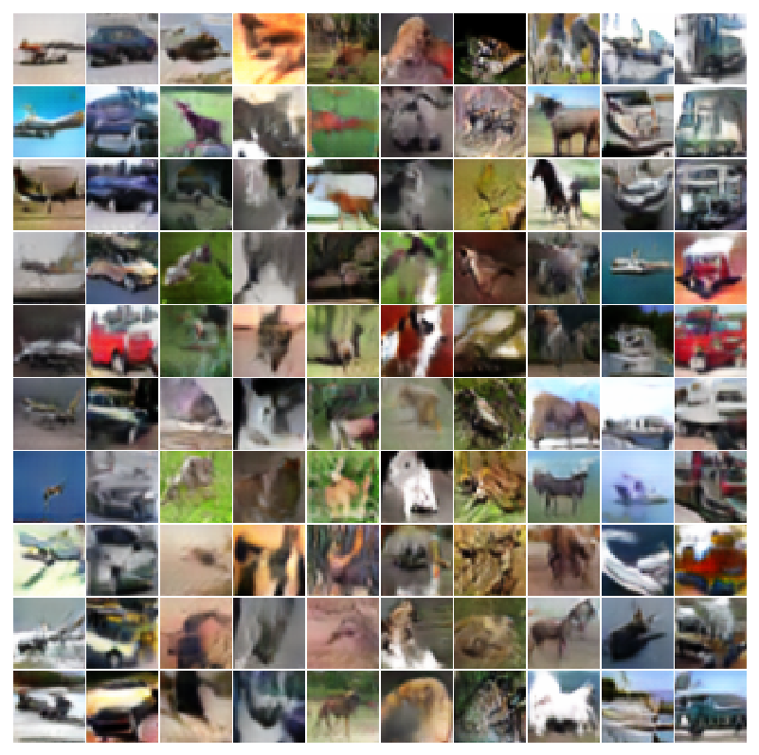

epoch 160 epoch 200

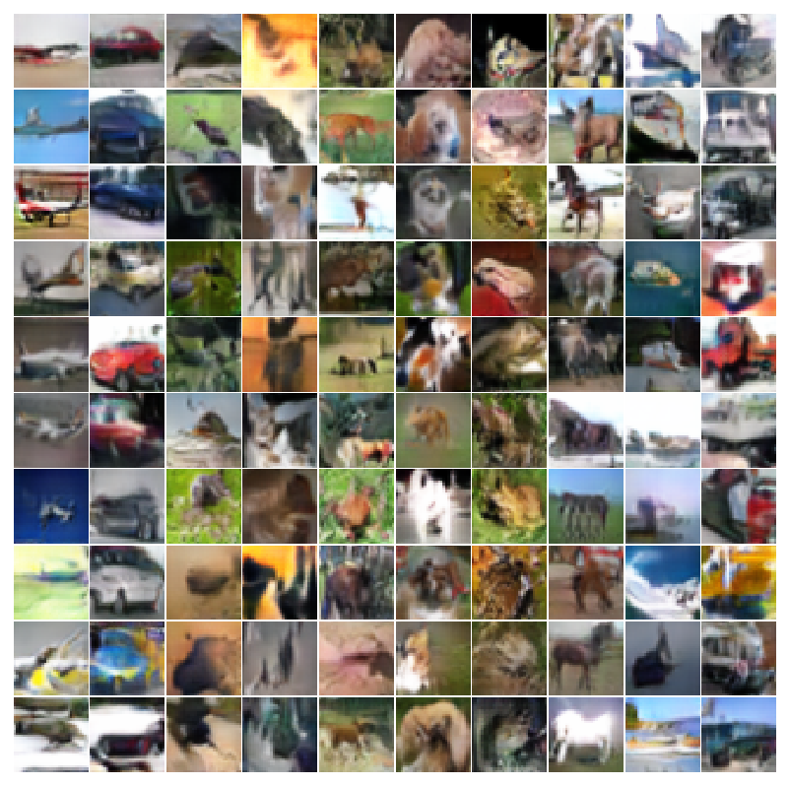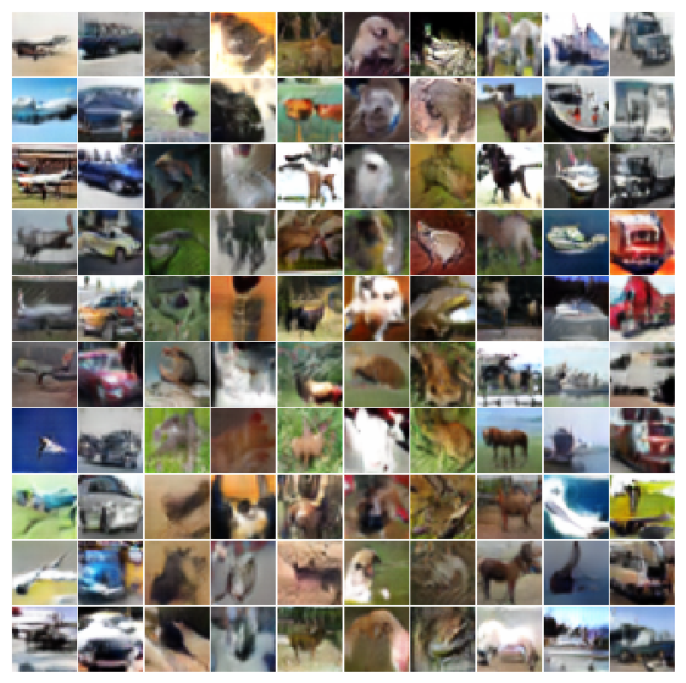

2. Fast Gradient Sign Method:

Original Accuracy: 90.625%

Adversarial Accuracy: 13.28125%

real image:

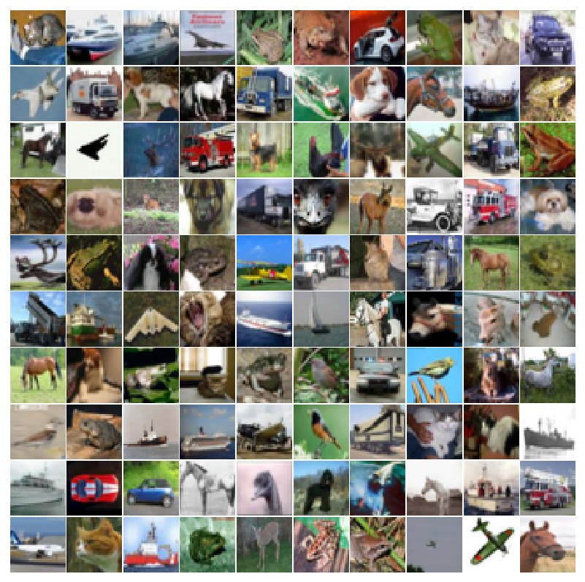

gradient:

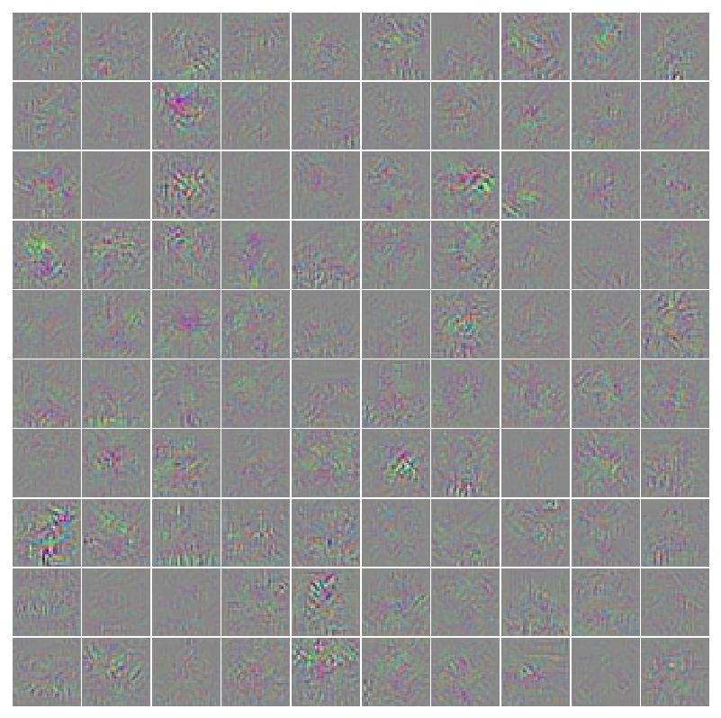

Adversarial images:

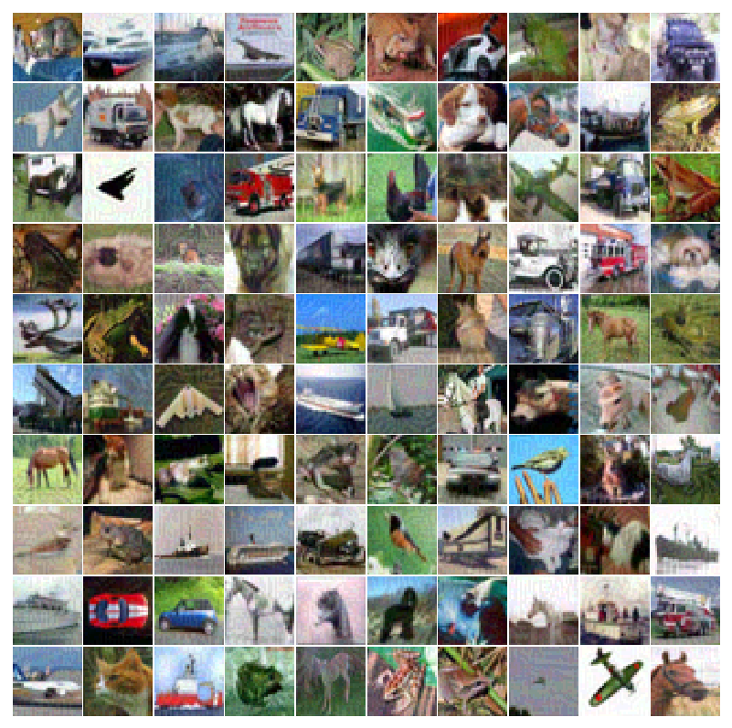

3. Synthetic images maximizing the class output

discriminator trained without the generator: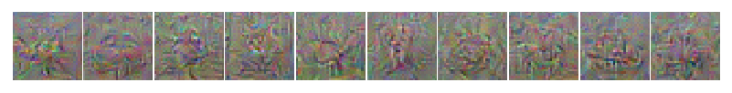

discriminator trained with the generator:

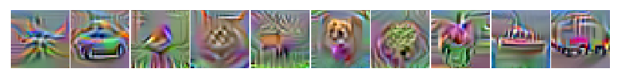

4. Synthetic images maximizing a particular layer of features

discriminator trained without the generator:

layer 4:

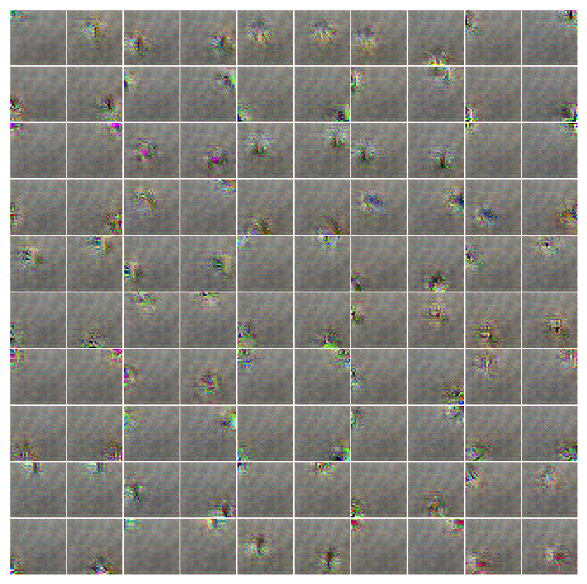

layer 8:

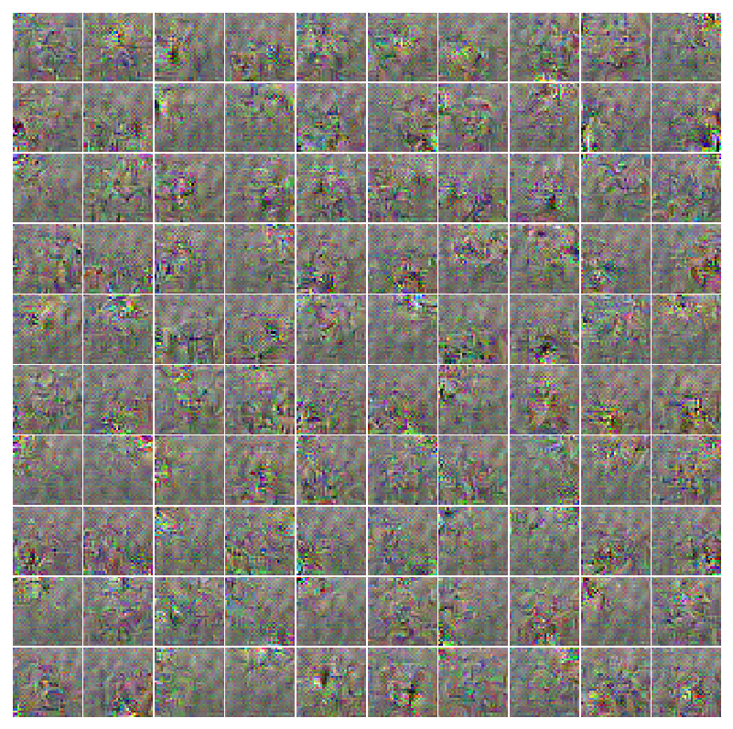

discriminator trained with the generator:

layer 4: 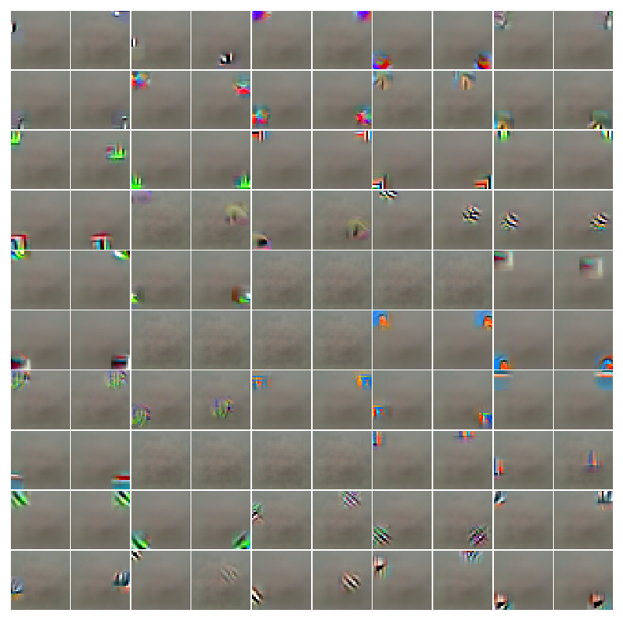

layer 8:

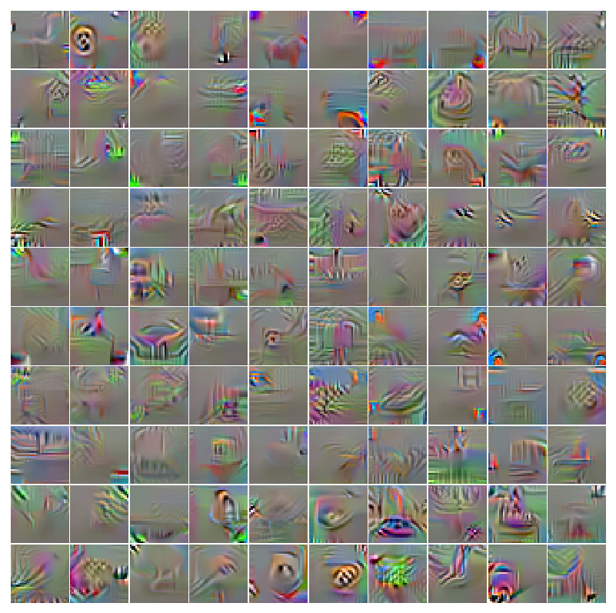

 5. Test Accuracy

 Discriminator trained without the generator: 89.07%

 Discriminator trained with the generator: 84.09533227848101%